Requirements
Working Menu Screen (Mandatory) 1.1
Pause Menu with quit and continue options (Mandatory) 1.2
Ability to Pick Up Blocks and move them around the screen (Mandatory) 1.3
Blocks moving right to left on screen and eventually off screen (Mandatory) 1.4
A grid system for packing boxes (Mandatory) 1.5
Score system (Mandatory) 1.6
System for generating different types of boxes (Mandatory) 1.7
A "work bench" area for placing boxes and blocks (Mandatory) 1.8
A system for playing background music (Optional) 5.0
A timer that ends when a "level" is over (Mandatory) 1.9

Game Loop (Happy Path)
Enters Main Menu
Hits button to start game
A box is created
timer starts ticking down from a starting time of three minutes
blocks start sliding across the screen
player drags blocks onto desk, back into conveyer or into a box's grid
Points are awarded when a box's grid is completely full
The full box disappears
Game loop continues until timer reaches 0
Player is shows total points
Player is prompted to play again or quit

UML Design
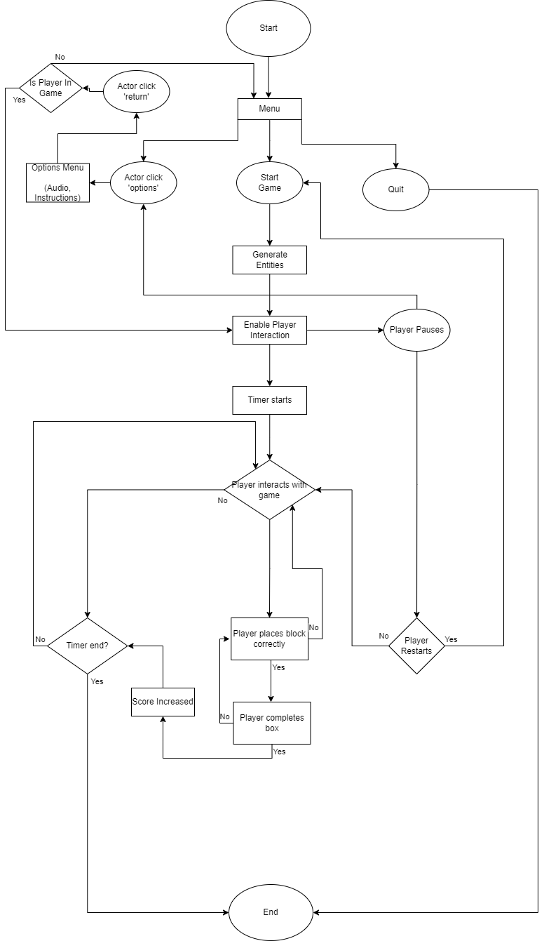
Requirements Checklist
1.1 - Check
1.2 - Check
1.3 - Check
1.4 – Partly (Generate Entities)
1.5 – Partly (Generate Entities)
1.6 - Check
1.7 – Partly (Generate Entities)
1.8 – Not Included
1.9 - Check
5.0 – Partly (Options Menu)

